DSA 3050A – Business Intelligence & Data Visualization
Practical Lab Assignment Report
Topic: Data Preparation Using Power Query
Student Name: Arlen Ngahu
Student Number: 667855
Unit: DSA 3050A

1. Introduction
AfriRetail Ltd experiences data quality challenges arising from multiple branches, staff, and non-standard reporting templates. The objective of this lab was to use Power Query in Power BI to ingest, profile, clean, standardize, integrate, and prepare analysis-ready data suitable for accurate visualization and decision-making.
All transformations were performed inside Power Query to ensure refreshable, auditable, and reproducible data preparation.

2. Task 1: Data Ingestion & Staging
Three raw datasets were loaded into Power BI using Get Data and transformed in Power Query Editor. Queries were renamed using BI naming conventions.
Queries Created:
- stg_Sales (Fact Staging Table)
- stg_Products (Lookup / Reference Table)
- stg_Regions (Lookup / Reference Table)
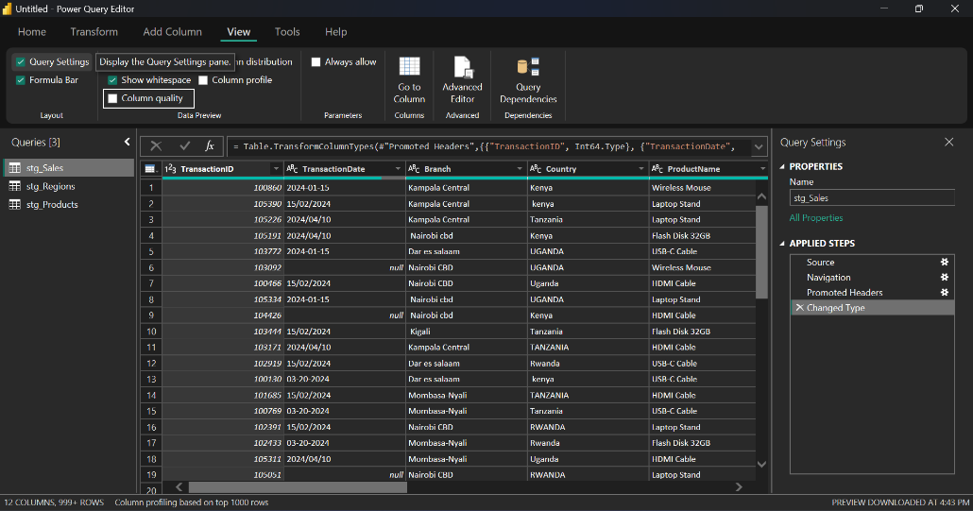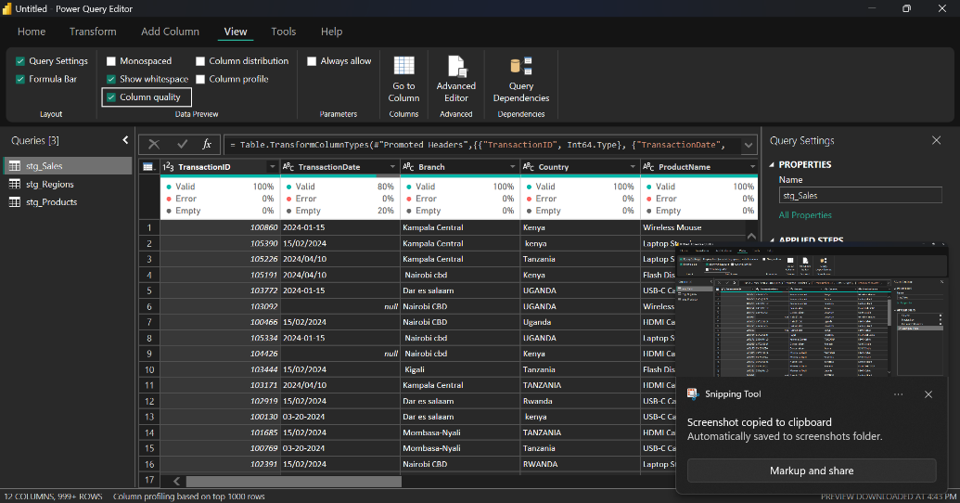
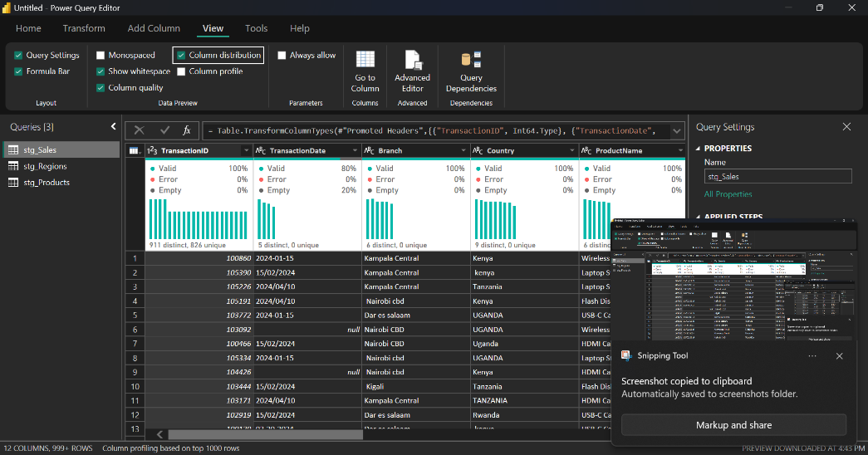
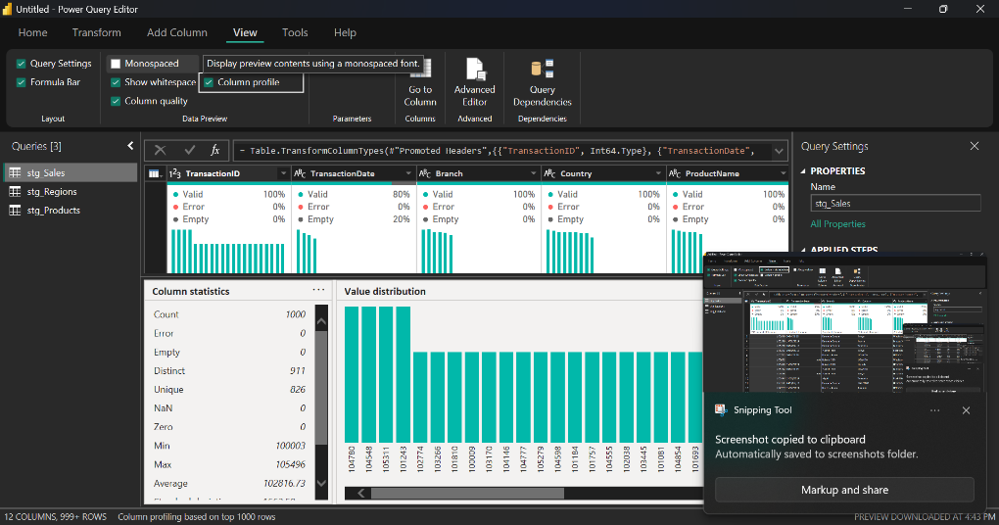

3. Task 2: Data Profiling & Quality Assessment
Power Query profiling tools (Column Quality, Column Distribution, Column Profile) were enabled to assess data quality.
Identified Data Quality Issues:
- Missing (empty) values in key columns
- Numeric fields stored as text
- Inconsistent casing and spacing in text fields
- Mixed date formats causing conversion errors
A DataQualityFlag column was created to categorize problematic records.
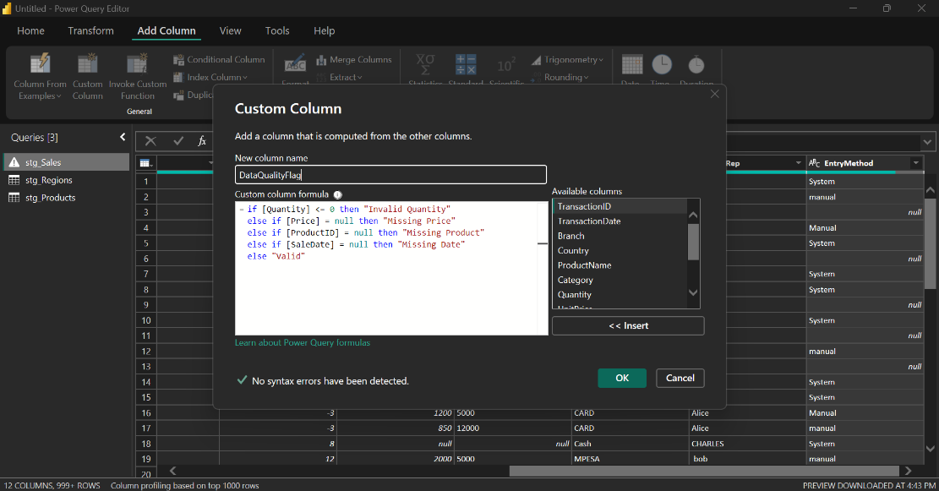
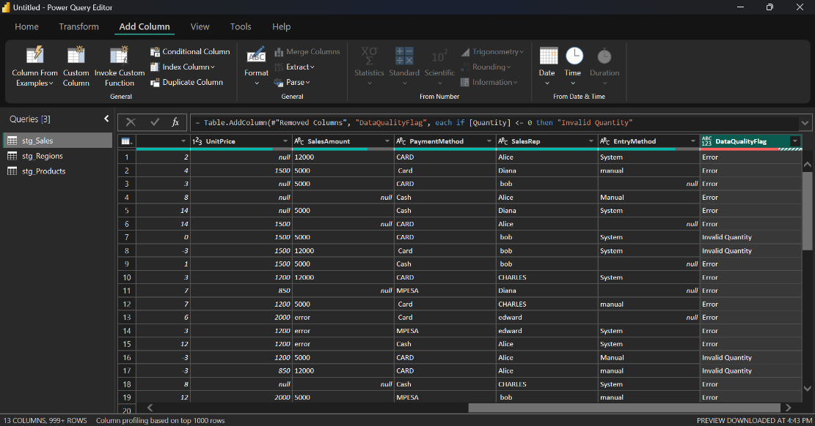
4. Task 3: Data Cleaning & Standardization
Cleaning and standardization were as follows:
- Text columns were trimmed, cleaned, and standardized to proper casing.
- Correct data types were enforced for all columns.
- Missing Quantity values were replaced with 0.
- Missing Category values were replaced with "Unknown".
- UnitPrice and UnitCost missing values were retained and flagged.
- Negative quantities were converted to absolute values using Quantity_Clean.
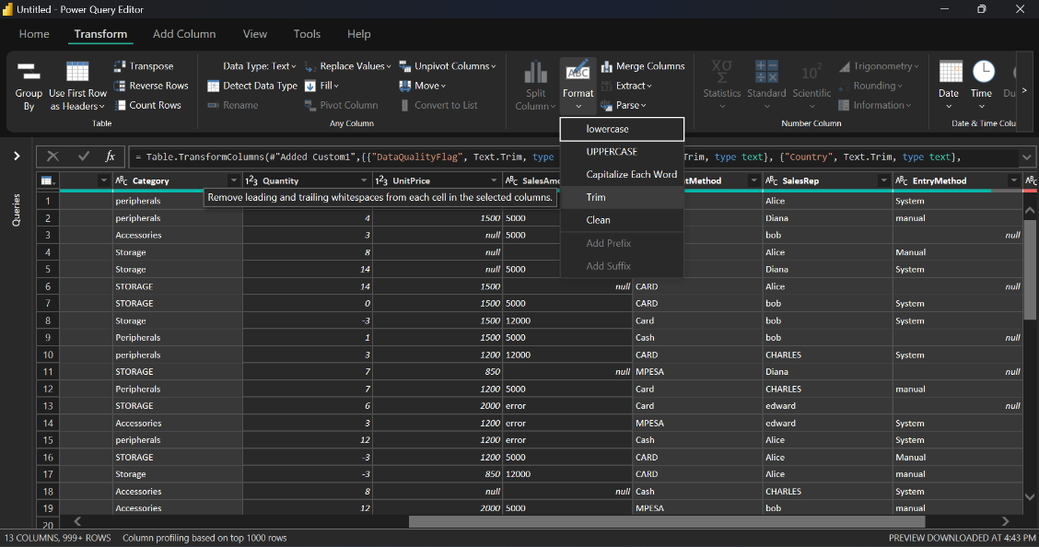
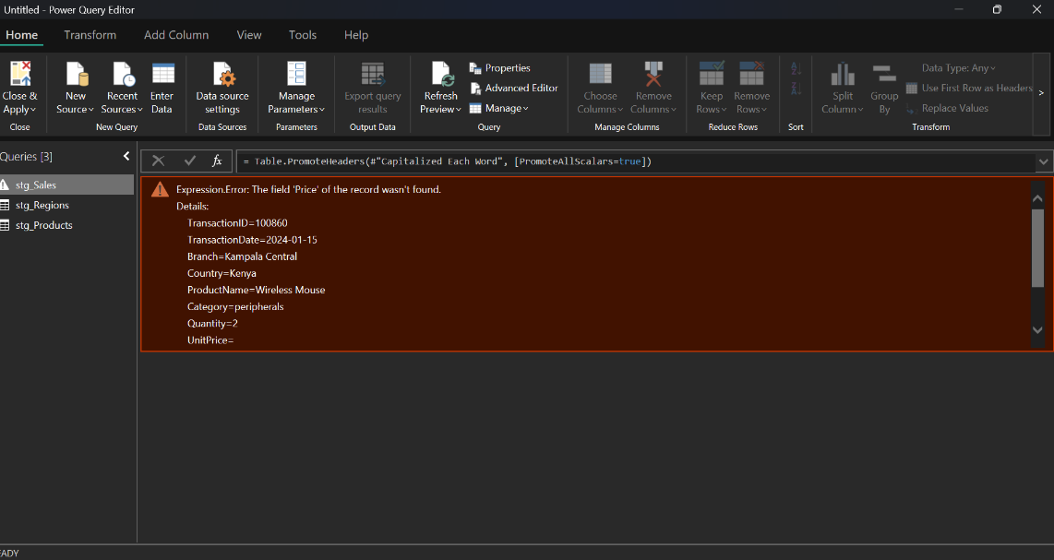
5. Task 4: Data Integration (Merge & Append)
Sales data was merged with product and region reference datasets using Left Outer joins to preserve all sales records.
- stg_Sales merged with stg_Products on ProductName
- stg_Sales merged with stg_Regions on Country
Unmatched countries were labeled using RegionStatus.
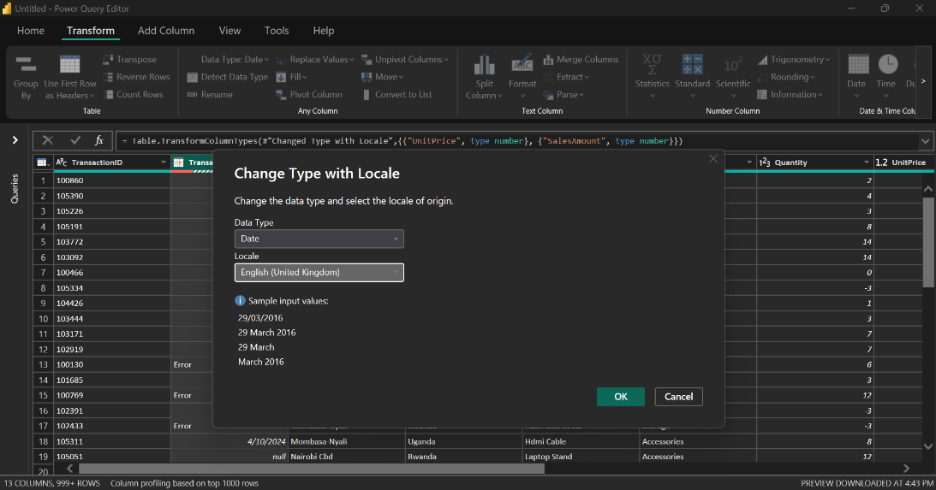
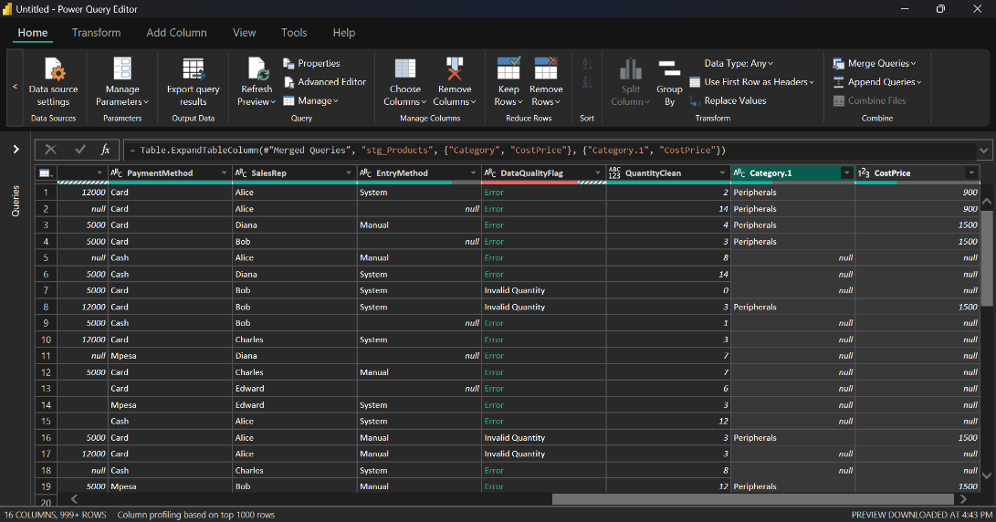
6. Task 5: Business Transformations
The following calculated columns were created using Power Query:
- SalesAmount_Calc = Quantity_Clean * UnitPrice
- Profit = (UnitPrice - UnitCost) * Quantity_Clean
- SalesBand (High, Medium, Low based on SalesAmount_Calc)
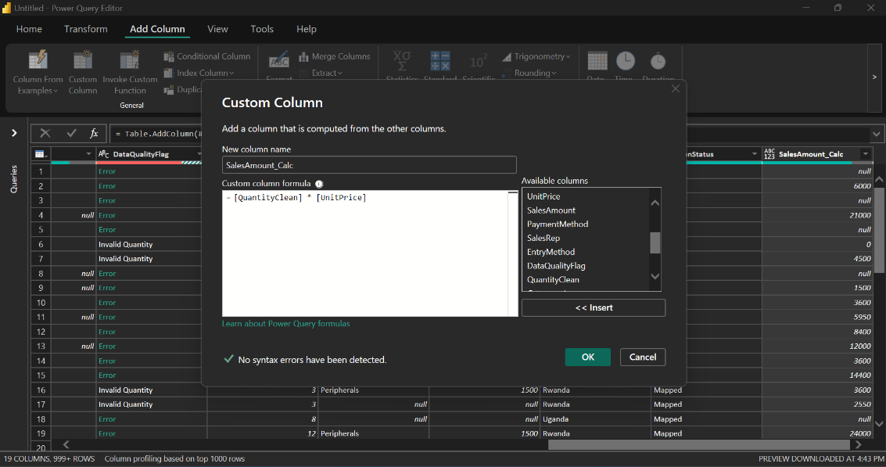
7. Task 6: Dimension Tables & Aggregation
Dimension tables were created using Reference and duplicates removed.
- dim_Product (ProductName, Category, UnitCost)
- dim_Region (Country, Region)
An aggregated summary table was created:
- agg_Sales_By_Country
  - TotalSales
  - TotalProfit
  - TotalQuantity
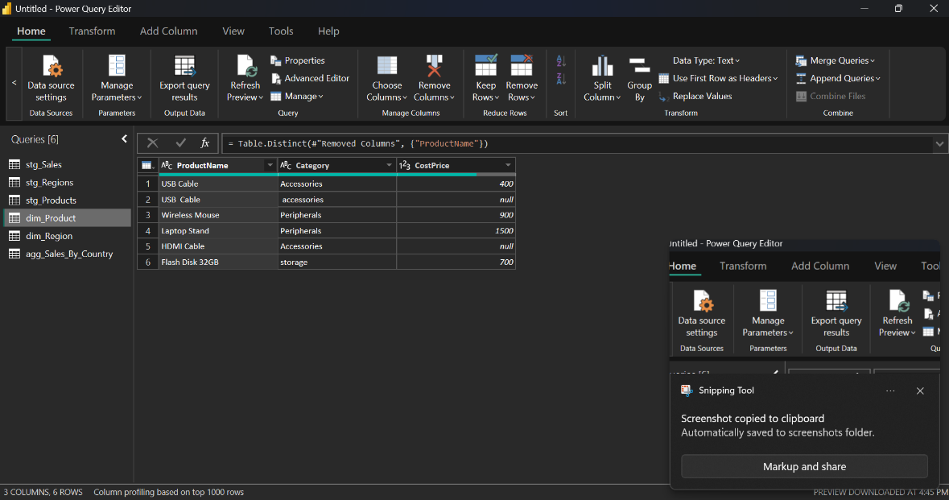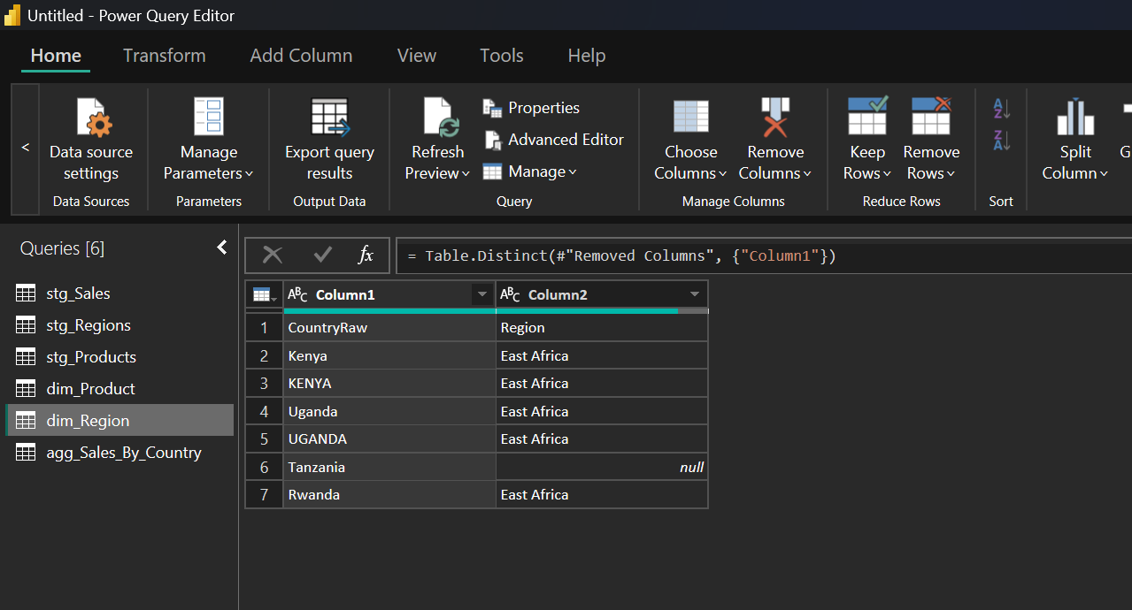
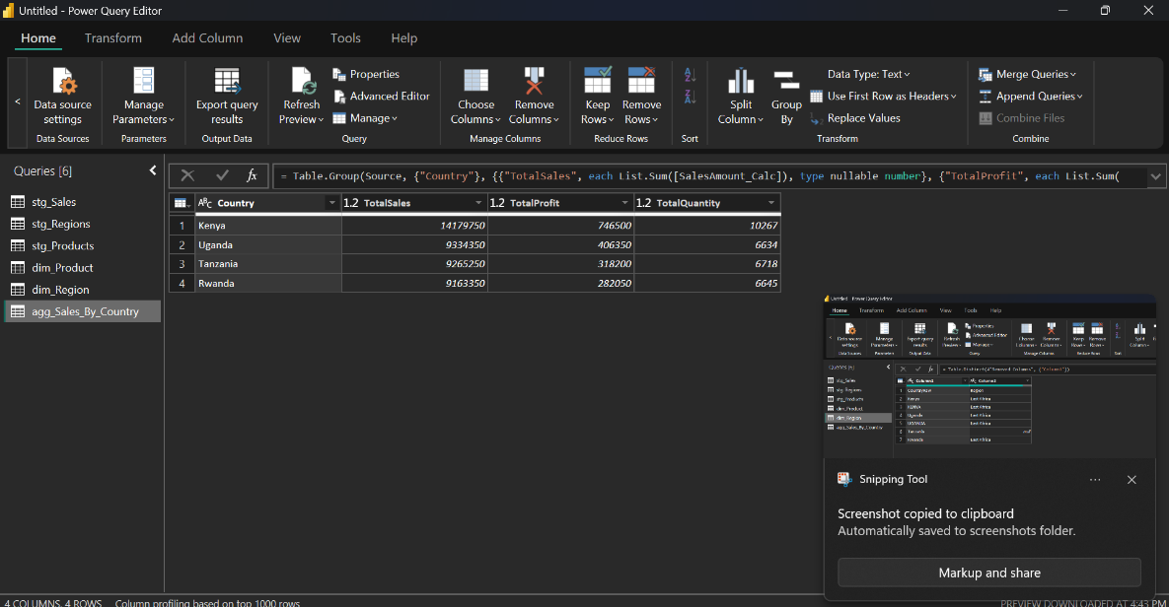
8. Task 7: Data Governance & Load Control
An audit query was created to isolate problematic records.
- audit_Sales_Issues (records where DataQualityFlag ≠ Valid)
Only analysis-ready tables were enabled for load into the data model.
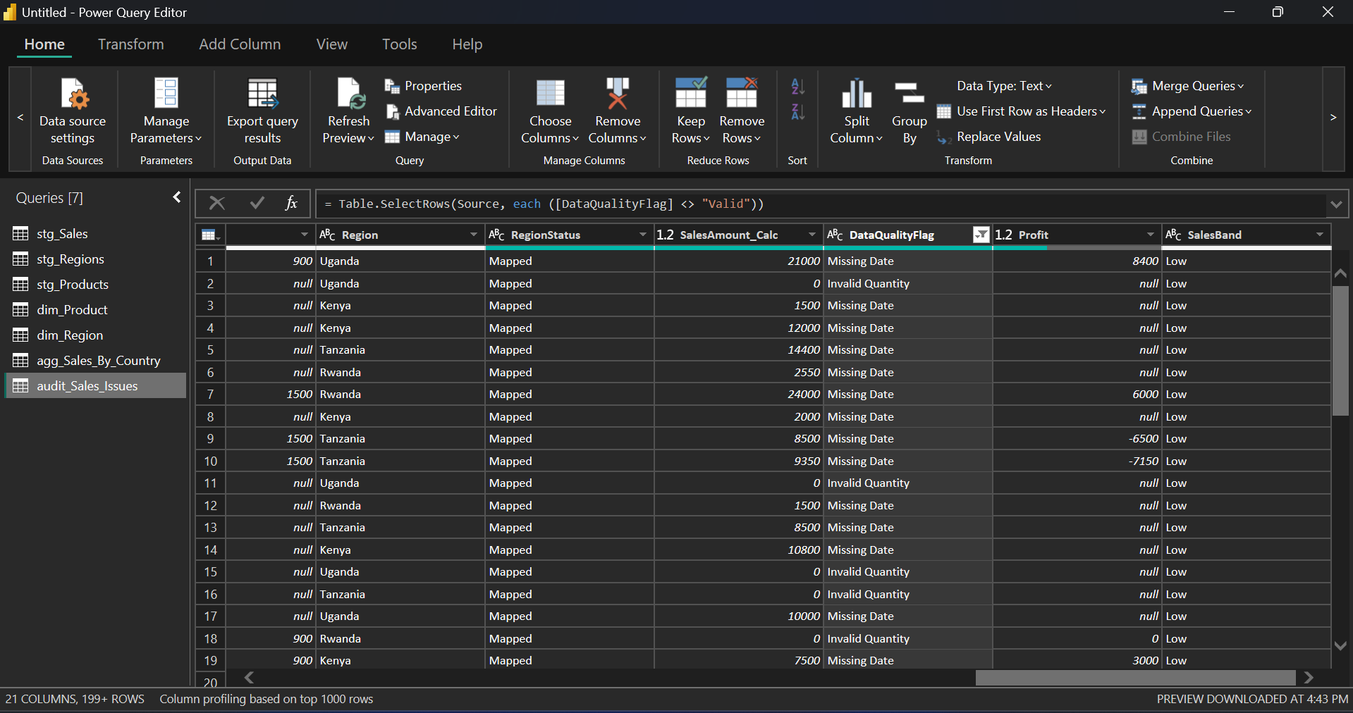
9. Conclusion
Power Query was successfully used to transform dirty, heterogeneous retail datasets into a clean, integrated, and analysis-ready data model. The prepared data supports reliable visualization, accurate reporting, and informed business decision-making for AfriRetail Ltd.

10. Appendix 